# Adding a Host in Zabbix: Step-by-Step Guide

## Step 1: Installing Zabbix Agent on a Host

Download the Zabbix Agent from the below link.

<https://cdn.zabbix.com/zabbix/binaries/stable/6.0/6.0.21/zabbix_agent-6.0.21-windows-amd64-openssl.msi>

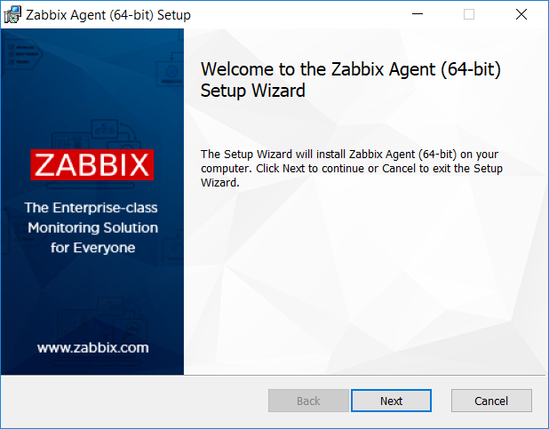

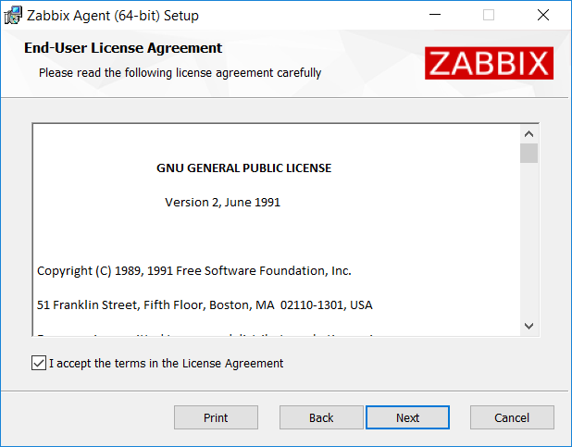

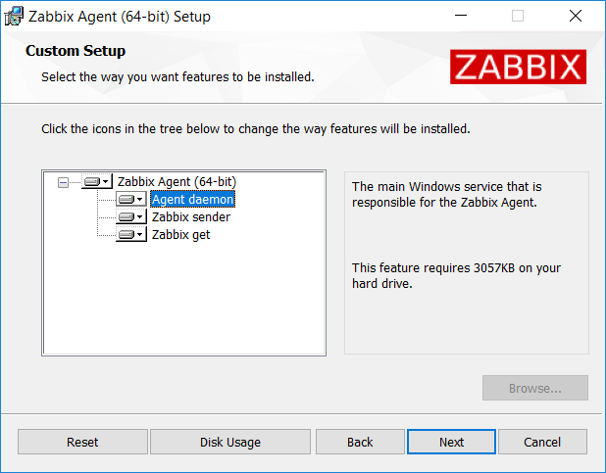

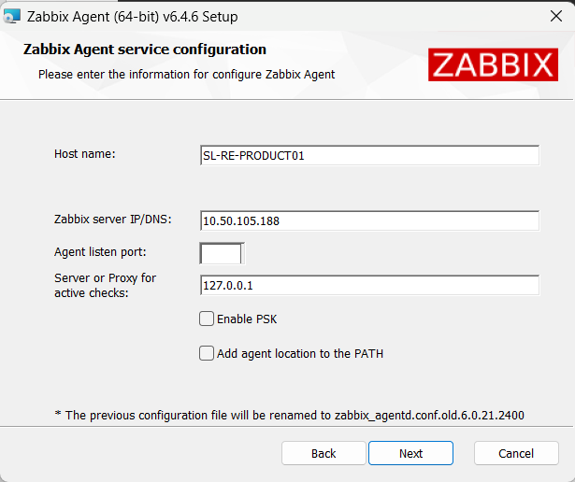

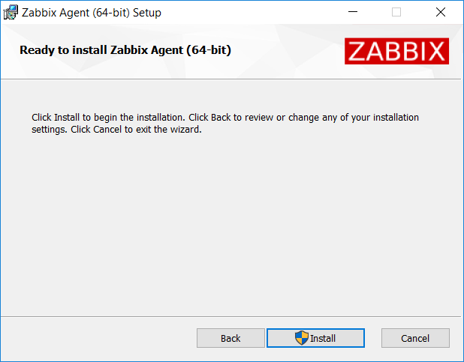

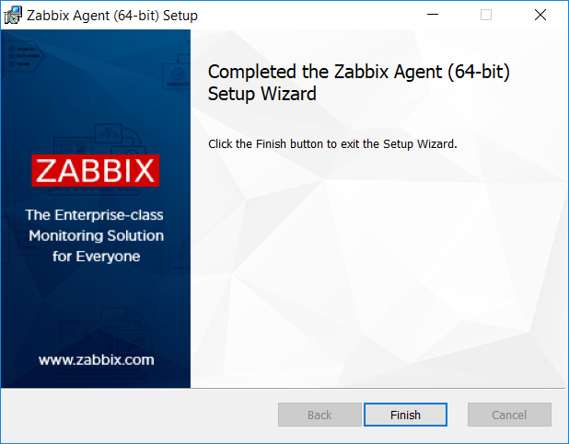

## Step 2: Access the Configuration Section

After logging in, you will be on the Zabbix dashboard.

In the top menu, click on "Configuration."

## Step 3: Add a Host

In the left sidebar, under "Hosts," click on "Hosts."

Click the "Create host" button located at the top right corner.

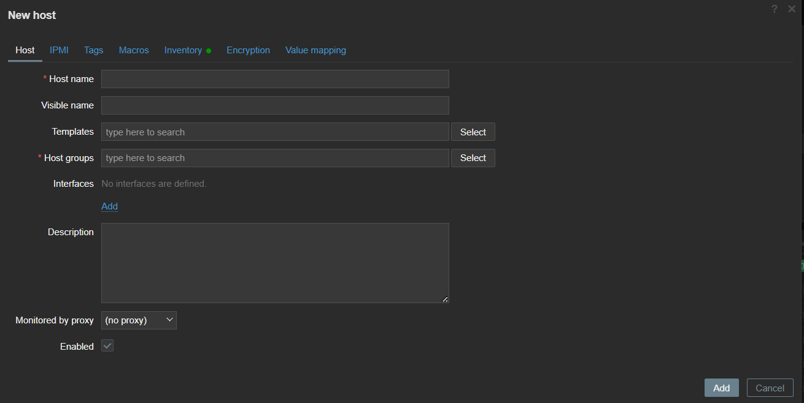

## Step 4: Configure General Host Settings

In the "Host" tab:

Enter a meaningful name for the host in the "Host name" field.

Optionally, add an alias for the host in the "Visible name" field.

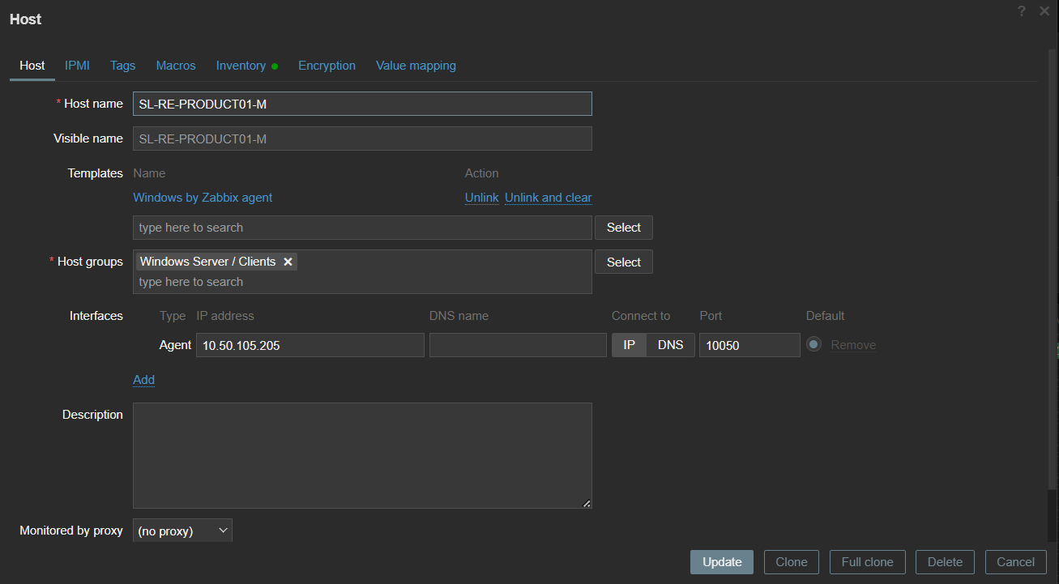

Choose a template and group for the host.





In the "Interfaces" tab: Click on "Add" to create a new interface for the host.

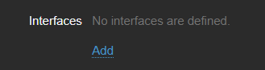

Choose the interface type (Agent, SNMP, JMX, etc.).

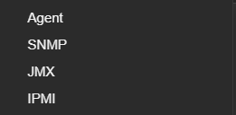

Enter the host's IP address in the "IP address" field.



Set the appropriate port and other interface-related settings.

In the inventory tab select Automatic  
click the "Add" button to create the host.

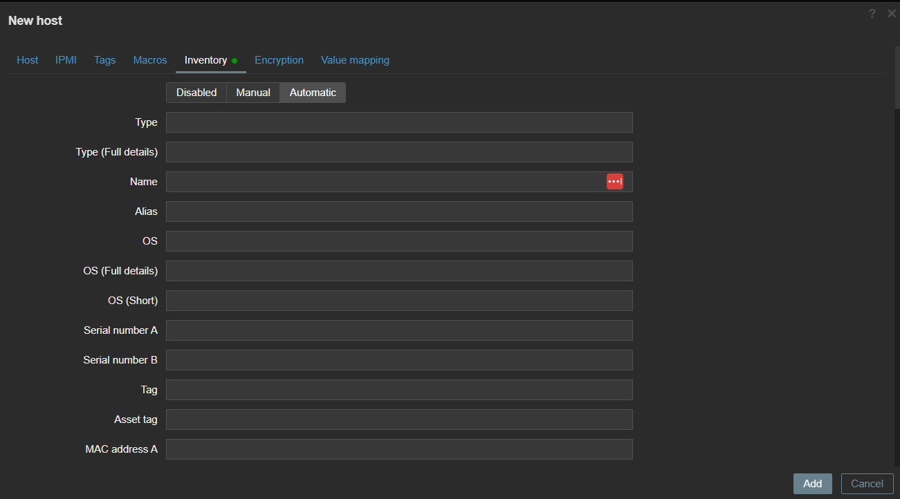

## Step 5: Start Monitoring

Zabbix will start collecting data from the newly added host based on the configured items and settings.Top of Form